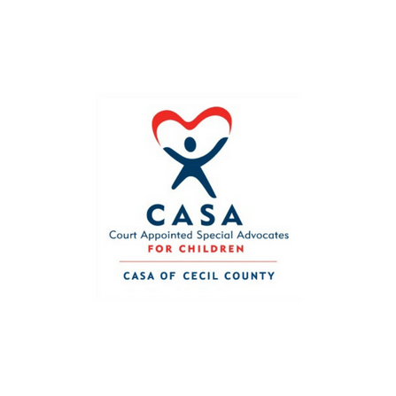

**April is Child Abuse Prevention Month. All children have the right to be safe, loved, and respected!**